TeamViewer Install Tutorial

Author: Max Slocum

Download team viewer from **teamviewer.com**

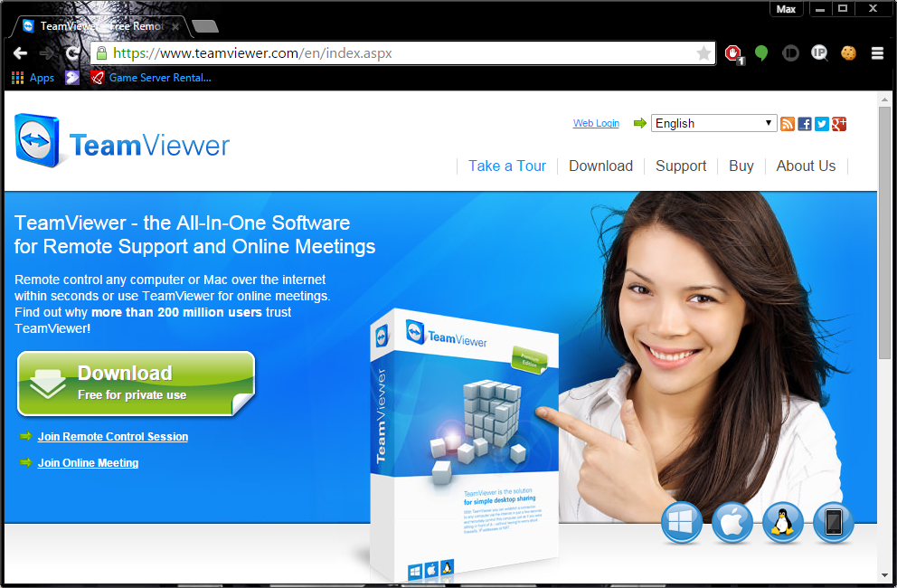

Click **Run** once this window appears

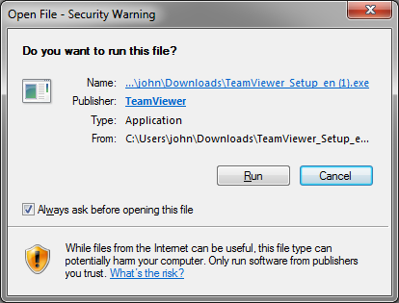

Next this window should appear, choose the same options as shown in the picture then click "Accept - finish".

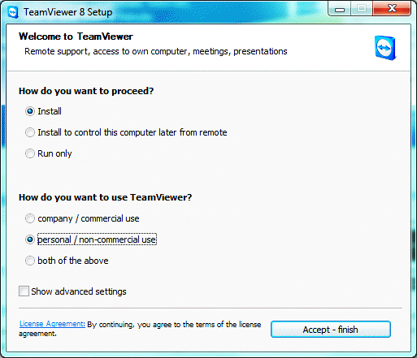

Windows will prompt you to allow the program to install once you click **Accept - finish**.

Click Yes (Allow).

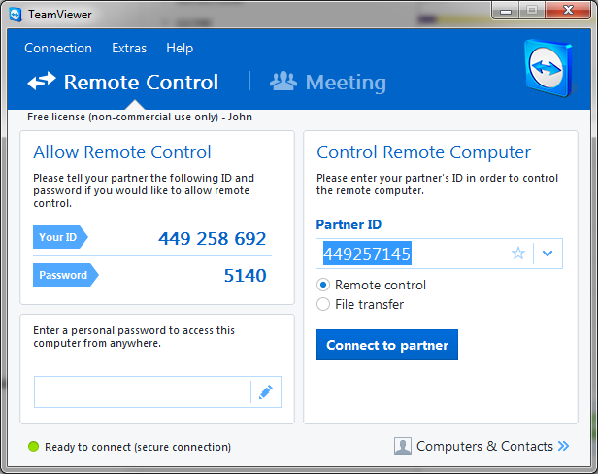

Your user **ID** and **Password** is needed for another user to remotely connect to your computer.